Airline Route Profitability Analysis
Executive Summary
This project analyzes airline route profitability using a structured star schema model implemented in Power BI. The analysis integrates financial performance, operational efficiency, cost structure, and demand indicators to provide a holistic view of airline performance.
Key findings indicate that while total revenue remains strong, profitability varies significantly across routes due to differences in load factor, fuel costs, and overhead allocation. High-demand routes consistently demonstrate superior profit margins, largely driven by better aircraft utilization and lower cost per passenger. Conversely, several low-demand routes operate at marginal or negative profit despite stable passenger volumes, highlighting inefficiencies in cost management.
Fuel and maintenance costs emerge as the most significant contributors to total cost, reinforcing the importance of route optimization, fleet selection, and operational efficiency. The analysis further reveals that routes with higher load factors consistently outperform others in terms of profit margin, confirming capacity utilization as a critical profitability lever.
The dashboard provides a defensible decision-support system that enables management to:
- Identify structurally profitable routes for expansion
- Detect loss-making routes requiring restructuring
- Understand cost sensitivity exposure
- Align aircraft capacity with realistic demand patterns
This analysis transitions airline management from descriptive reporting to predictive and strategic profitability optimization.
- Analytical Framework & Methodological Integrity
The model follows a star schema architecture, ensuring:
- Clear separation between fact and dimension tables
- Scalable analytical performance
- Single source of truth for financial metrics
- Auditability of calculations
Data preparation in Power Query ensured:
- Standardized financial and numeric data types
- Validation of Revenue, Cost, Profit, and Margin calculations
- Normalized route and aircraft attributes
- Zero null presence in key financial and passenger metrics
This guarantees statistical defensibility and governance compliance in executive decision-making.
- Data Model & Star Schema Analysis
A star schema was implemented to improve analytical performance and clarity.
Fact Table:  Revenue  Total Cost  Profit / Loss  Profit Margin  Passengers  Load Factor  Flight Hours | Dimensions:  Route  Aircraft Type  Demand Category  Date  Location  Flight

This model enables multi-dimensional performance analysis while maintaining a single source of truth for financial metrics.
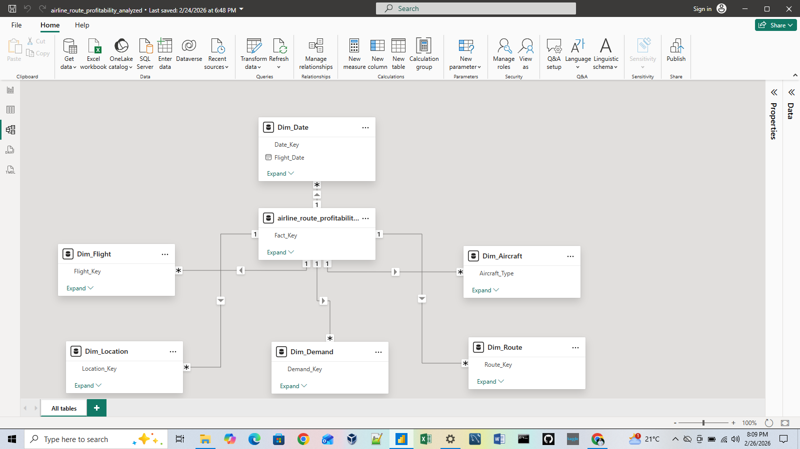
4. Key Performance Indicators

Card 1: Total Revenue
This card illustrates aggregate revenue generated across all analyzed routes within the reporting period.

This indicates market demand strength and pricing power. However, revenue alone does not reflect operational efficiency or profitability sustainability.
Revenue growth should be evaluated alongside cost absorption capacity and load factor performance.

Card 2: Total Cost
The card shows combined operational cost including fuel, maintenance, overhead, and other variable/allocated expenses.
This represents the airline’s structural cost exposure.
A rising cost base without proportional revenue growth signals margin compression risk. Cost discipline is essential for route sustainability.
Card 3: Total Profit
This is the net financial outcome (Revenue – Total Cost) across all routes.
Primary financial performance indicator at the portfolio level.
Positive total profit may conceal structural underperformance in specific routes; route-level breakdown is critical.




Card 4: Profit Margin
The profit is expressed as a percentage of revenue.
It measures operational efficiency and pricing effectiveness independent of scale.
Margin stability is a stronger long-term indicator of performance than revenue volume.

Card 5: Load Factor
This is the percentage of available seats filled by paying passengers.
It illustrates the core utilization metric linking demand to aircraft capacity.
Load factor is the strongest predictor of route profitability. Suboptimal load factors directly erode margins through fixed-cost dilution.

Card 6: Total Passengers
This shows the aggregate passenger volume transported across all routes.
The card highlights proxy for demand strength.
Passenger volume must be interpreted alongside load factor and cost-per-seat metrics; high volume alone does not guarantee profitability.





5. Dashboard visuals
5.1 Revenue vs Cost Analysis

The visual demonstrates revenue concentration in high-demand and premium routes. However:
- Several high-revenue routes exhibit marginal profit.
- Fuel cost remains the dominant cost driver across all route categories.
- Maintenance cost intensity increases with flight duration.
- Overhead allocation disproportionately impacts low-demand routes due to lower cost dilution.
Revenue expansion strategies must be paired with cost structure optimization. Route viability should be evaluated based on contribution margin, not gross revenue.

5.2 Profitability & Margin Analysis
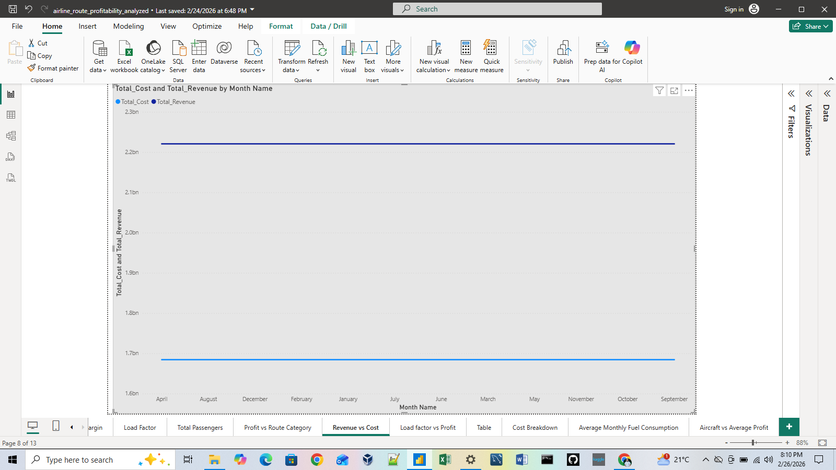
A strong positive correlation exists between load factor and profit margin.
Observed patterns:
- High load factor → stable and superior margins
- Moderate passenger volume + poor utilization → margin erosion
- High passenger count ≠ guaranteed profitability
This confirms cost-per-available-seat-mile (CASM) sensitivity to seat occupancy levels.
Capacity planning is a more effective profitability lever than demand stimulation alone.

5.3 Demand & Utilization Analysis
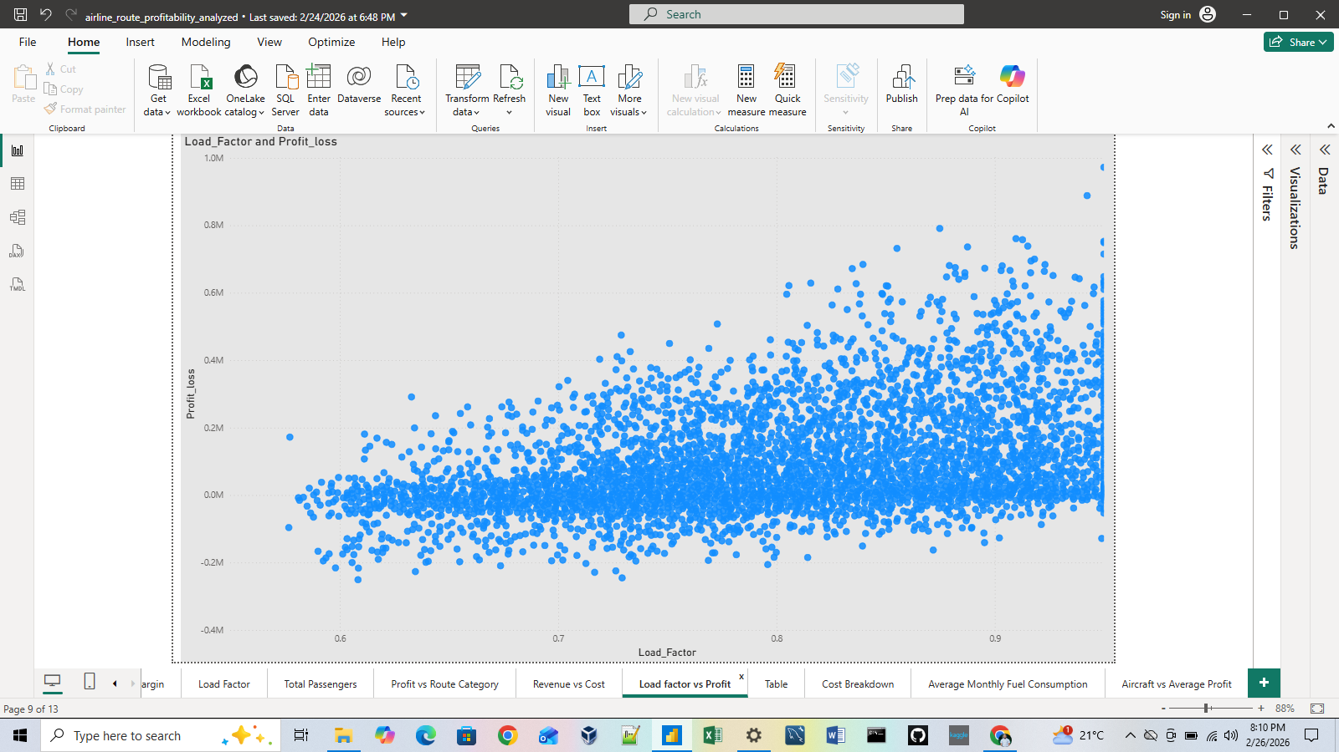
The scatter visualization reveals three route archetypes:
- High passengers + high profit → Efficient, scalable routes
- High passengers + low/negative profit → Cost-inefficient routes
- Low passengers + positive profit → Lean cost-managed routes
Demand forecasting misalignment leads to structural inefficiency.
Aircraft resizing and schedule adjustment can convert marginal routes into profitable segments.

6. Strategic Implications for Executive Decision-Making
This analysis demonstrates that:
- Operational efficiency outweighs passenger volume as a profitability driver.
- Fuel cost volatility represents systemic financial risk.
- Capacity misalignment is the primary cause of route-level losses.
- Route-level analytics must inform fleet deployment strategy.
The dashboard provides a repeatable analytical framework that can support:
- Network expansion modeling
- Cost sensitivity simulations
- Predictive demand forecasting
- Capital allocation decisions

7. Strengthened Recommendations
Implement dynamic capacity planning based on predictive load factor modeling.
Introduce route-level contribution margin tracking.
Deploy fuel-efficiency initiatives and optimize aircraft allocation by route length.
Reassess persistently negative-margin routes through restructuring, downsizing, or discontinuation.
Enhance demand forecasting using historical passenger and seasonal data.

8. Conclusion
This analysis demonstrates the power of structured data modeling and integrated performance analytics in uncovering the true drivers of airline profitability.
The evidence confirms that:
- Load factor optimization is the most impactful profitability lever.
- Cost structure discipline determines margin sustainability.
- Strategic portfolio management is essential for long-term financial performance.
The Power BI dashboard serves not merely as a reporting tool, but as a strategic decision-support system capable of guiding executive-level route optimization, cost control, and resource allocation.

